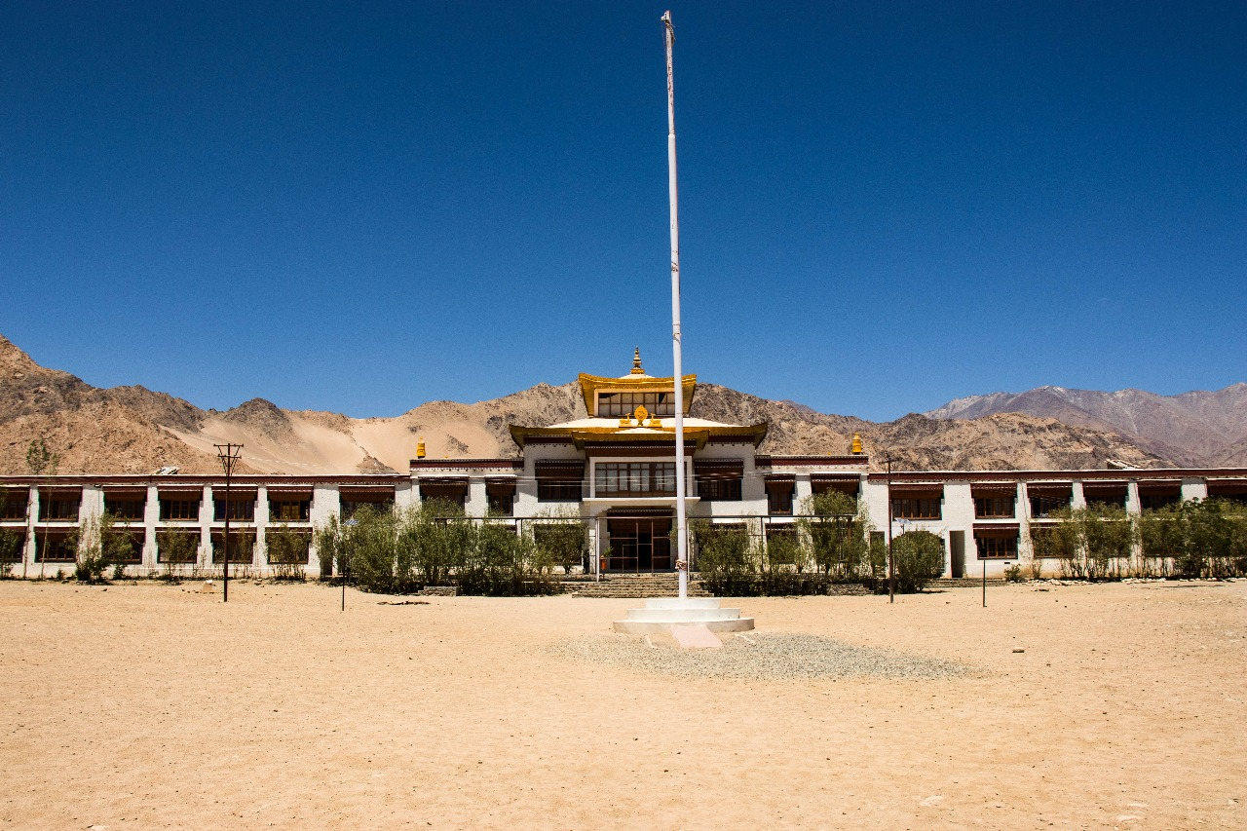
The Magic of Druk Padma Karpo School – Rancho’s School
After the serene experience at Hemis Gompa Monastery, our second and final stop of the day was one I had been looking forward to for years—Druk Padma Karpo School, famously known as Rancho’s School from the movie 3 Idiots.
Being a huge fan of the film, I couldn’t contain my excitement. The hilarious scenes, the unforgettable dialogues, and the heartwarming story had made this place almost legendary in my mind. Walking into the school felt surreal, as if I had stepped onto the very set of the movie.
The school was incredibly well-maintained, its walls still adorned with the same vibrant paintings seen in the film. It was fun pointing out different spots and reenacting some of the funniest scenes with my family—we laughed, played around, and relived the joy that the movie had given us.
What made the visit even more meaningful was learning that the revenue collected from visitors was used for the education of the children and the upkeep of the school. It wasn’t just a tourist attraction; it was a place that continued to nurture young minds and create a future for them.
As we explored, I noticed a striking new white building nestled between the mountains, standing like a symbol of progress and beauty. It was breathtaking. I wished I could stay until sunset to watch the golden rays kiss its walls, turning it into something even more magical. But unfortunately, our tour guidelines didn’t allow us to linger that long.
Still, the sight of children studying, playing, and curiously watching the visitors made me pause. I wondered what it must be like to study in a place like this, surrounded by such majestic landscapes. How could anyone focus on books when the peaks and clouds outside seemed to whisper adventure?
Just imagine playing your favorite sport here, with the whole school cheering you on, the crisp mountain air filling your lungs. It wouldn’t feel like just a school—it would feel like a dream.
As we left, I took one last look at the school, soaking in its beauty, its energy, and the memories it had given me. It wasn’t just Rancho’s School anymore—it had become a part of my own story.

